6A^{th} Grade: Unit 13, Lesson 5

- Write the numerical expression that represents “the quotient of 75 and 15”.

$$75 ÷15$$

- Write the numerical expression that represents “44 decreased by 17”.

$$44-17$$

- Which diagram represents “the product of 7 and 9 is 63”?
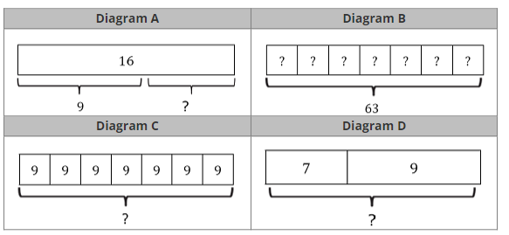

Diagram C
- Elaina is 13 years old and her cousin is 6 years older than her. How old is her cousin?

$$19$$

- Every classroom at a middle school had a maximum capacity of 30 students. If there are 75 rooms, what is the maximum combined capacity of all the classrooms at the school?

$$2,250$$

- Ailany bought 6 boxes of cupcake mix, with each box costing $3. How much did she spend in total on the cupcake mix?

$18

